Benny Iko

6/15/2021

SWEN 603 9040 Modern Software Methodologies

XP methodology critique

XP or “Extreme Programming” is an Agile methodology used to create software. Similar to other Agile practices, XP boasts frequent releases or increments in short development cycles. The SDLC is based on five values: communication, simplicity, feedback, courage and respect. Extreme Programming quickly and effectively delivers business value to the customer with no design up front. Some advantages of this approach are feedback, code ownership,and the emphasis placed on testing. Criticisms include customer involvement, approach to design and pair programming.

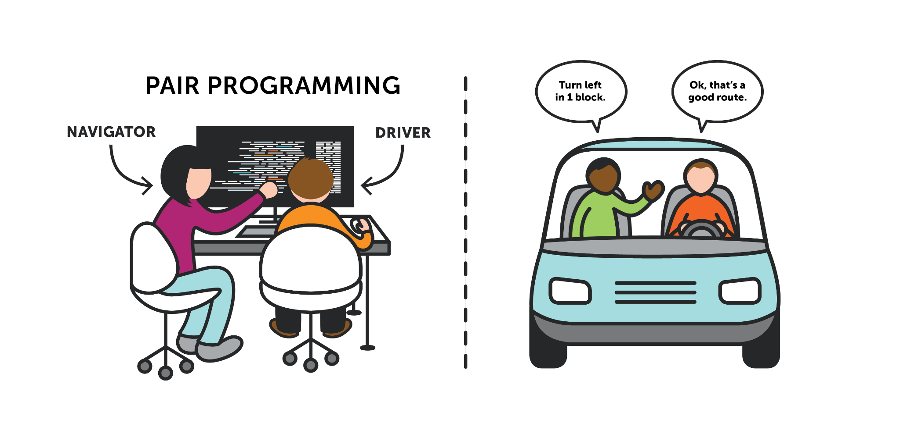
Pair programming (pictured above) is a prominent feature of Extreme Programming. A “driver” and “navigator” work together to produce code. Benefits of PP include program correctness and higher software quality. Feedback is another key aspect of XP; it comes from various areas during development, leading to a better software product as an end result. For example, programmers receive instant feedback from the system through unit tests and periodic integration tests. As a result, issues are spotted quicker and the cost of changes is reduced. The ability to spot bugs early is a pro of development using this Agile method. This is possible due to the immense amount of focus placed on testing. Acceptance or functional tests serve as feedback from the customer. The value of courage is embodied through the empowerment afforded to programmers. Developers are comfortable with altering their code when necessary. This is reinforced through the idea that programmers should only code what is needed for today or the minimum requirements. This allows for more flexibility and accounts for the possibility of changing requirements.

XP is the topic of many skeptics. Common criticisms include customer involvement, the controversial approach to design and pair programming. There is no design up front with this methodology, as this practice views the code itself as the most important part. Requirements are defined incrementally,as opposed to attempting to gather them all in advance. Embracing change is a fundamental principle of this particular life cycle. When customer requirements are very fluid, XP is built specifically to handle such changes. However, the perception is that lack of design documentation and unorthourthadox approach ends up being costly in the long run. Pair programming, despite its benefits, is also the target of many debates. The extended time it takes to complete projects has been cited at around 10%. This time could arguably be spent better, instead of having two programmers focus on the same task.

I think mission critical projects are ideal, but only when paired with other complementing Agile methodologies. I think the lack of planning for this methodology would be an issue for such a project. However, the extensive amount of testing and pair programming techniques would work for this application. Other projects that would benefit from this management style, are those in an industry where requirements change rapidly. For example, automotive sales would be an ideal candidate. I used to sell cars for a while, and different sales and promotions brought along different requirements to meet such promotions. The finance calculator on the web app may need to be updated biweekly, and the inventory changes often. These factors need to be accounted for when considering the best approach to manage the software.

